Asking the Response question.
Students practice building continuous dialogue.
Do after activities on Active Listening…
NB We will use the term “Response Question” throughout.

Dialogue Skills 
Active Listening 
Cooperation 
Conflict resolution 
Reflection ➔

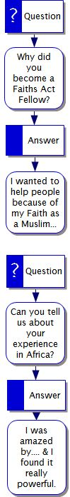
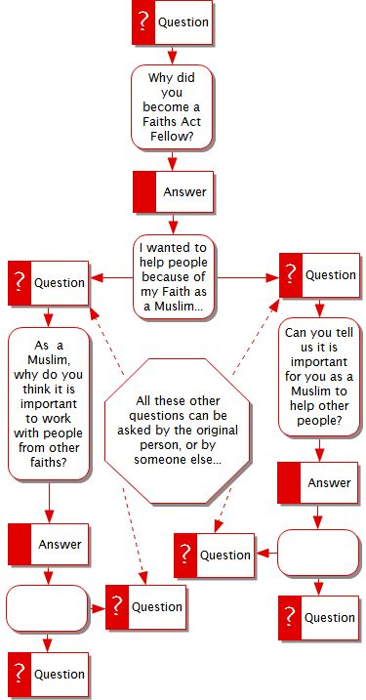
This is a very important skill for students in a videoconference – and can make the difference between a disconnected series of questions, and a proper dialogue. This is an activity that students need to practice in order to build up their skills, so as well as doing the activity at this point, try using the same methodology when students share ideas at another point before the VC (you can even use it as a Plenary) .

Introduce by starting students off on the Activity "We're all interviewees" Group students into groups of 4, and get them to start the Interview, using a simple, fun question like “What do you do for fun?”

After 2 students in each group go, then introduce the idea of the second question to students by referring to these two diagrams on the powerpoint.

Ask them which one is better in terms of generating information!

Get them to go back to the Interview activity, but to practice the last two interviews making sure that they use this methodology. (Sometimes it is impossible, and you do need to ask a new question – but in general this is the principle that they should use).

