Dr Manpreet Dhuffar Pottiwal: Sikh Psychologist


Watching Dr Manpreet Dhuffar Pottiwal’s TEDx talk deeply moved me because of her advocacy for South Asians and her insights on intergenerational trauma. She uses the metaphor of family trees to explain this: our roots carry our DNA and shape who we are, the leaves are burdens inherited from elders, and the fruits are the gifts they leave us.
Her work shows that by understanding our roots, we can release some of the burdens while embracing the sweetest fruits. As a British South Asian intersectional feminist and Chartered Psychologist, she combines clinical expertise with activism, decolonising therapy and promoting fairness in multigenerational living. Watching her talk helped me reflect on my own positionality and see how culture, family history, and psychology intersect, highlighting the importance of empathy, community, and understanding in healing.

As a teacher, you can take clips from her TEDx talk to show students a modern Sikh who draws on her lineage to understand her roots further, you could invite students to reflect on the fruits of living in a multigenerational household - this could provide a useful discussion in units about family and relationships.

Mai Bhago: Female Sikh warrior

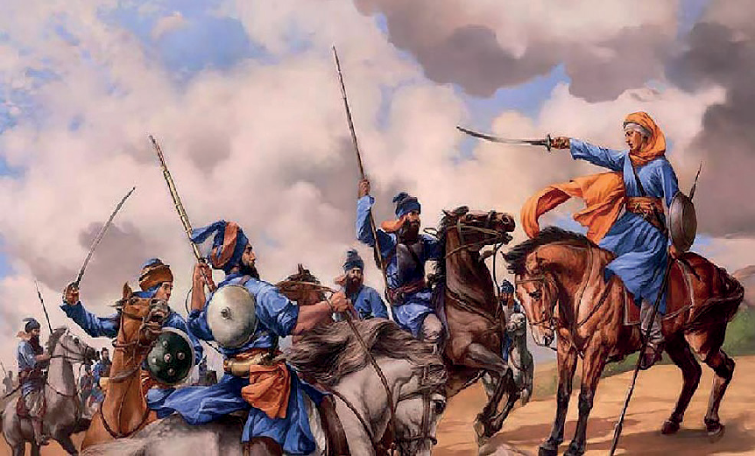
During the early 18th century, the Mughal Empire launched a siege against Guru Gobind Singh at Anandpur Sahib, leading to such extreme hardship that 40 Sikhs signed a formal disclaimer renouncing their faith to escape. When Mai Bhago - the first female warrior in Punjabi history, discovered her husband and others had deserted, she confronted the men, shamed them for their cowardice, and persuaded them to seek the Guru’s forgiveness. As they journeyed to find him in the Malwa region, they encountered a pursuing Mughal army of 10,000 soldiers at the pool of Khidrana.

Despite being vastly outnumbered, Mai Bhago and the forty men charged into battle with such ferocity that the Mughal forces eventually retreated. Watching from a nearby hill, the
Guru rushed to the field to find all forty men martyred or mortally wounded. The dying leader of the group, Mahan Singh, watched as the Guru lovingly tore up their letter of resignation, forgiving them and blessing them as the Chali Mukte (the 40 Liberated Ones). Mai Bhago, who was injured in the fight, recovered and served as the Guru’s bodyguard until his passing in 1708.
Teachers can use this to show how a great historical example of women who were for the first time expected to take arms to protect themselves just like men - showing equality not in theory but in practice – she was the only survivor of that siege and became Guru Gobind’s bodyguard during his final years!

Amrita Sher Gill: Hungarian Sikh artist

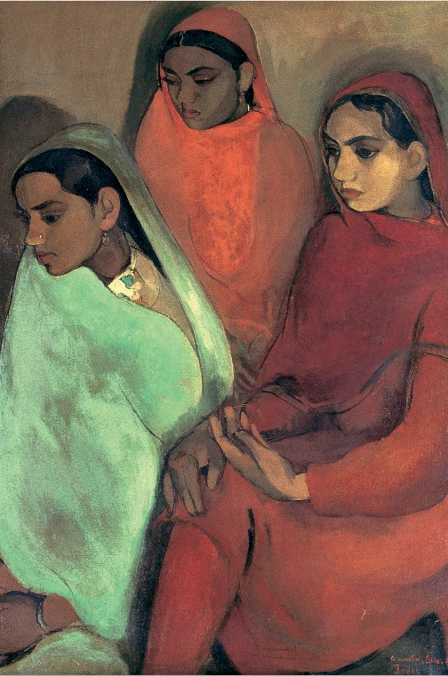
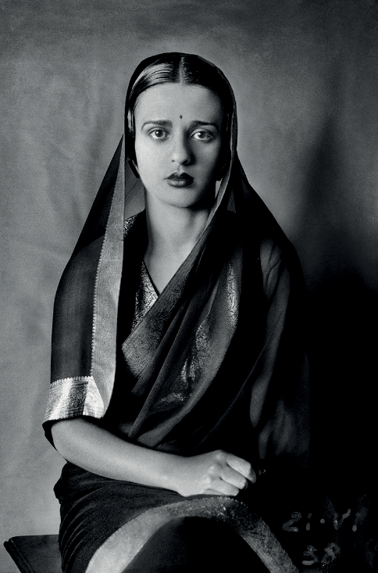
Amrita Sher Gil’s work has always inspired me because it captures the emotional depth and struggles of women whose lives were often predetermined by tradition. Seeing her paintings, I can’t help but connect them to the stories of my own aunts, my grandma, and even my mum—the sense of lives shaped by expectations and choices already made for them.

In particular, her painting Three Girls struck me deeply: the three cousins she portrayed embody the quiet exhaustion and melancholy of girls bred for marriage, heading toward a future they cannot control. The expressions, posture, and mood of the painting communicate a mixture of resignation, sadness, and suppressed strength, reflecting the range of emotions that so many women carry.
Through her blending of Indian and European techniques, Amrita not only documented these realities but gave them a universal voice,showing both vulnerability and resilience in a way that continues to move me profoundly – the three cousins painted here are her first cousins!
Teachers can use this as a lens to discuss relationships, specifically arranged marriage despite being a thing of the past. Lots of students may find themselves connected to those who had an arranged marriage with lots of stories and evaluation on different cultures. It's useful in GCSE when we discuss marriage, roles expectations etc.

Neelam Kaur Gill: British Sikh model

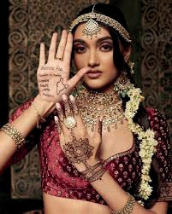
Neelam Gill has transformed her experience of childhood bullying in Coventry (where she was born) into a powerful mission for global representation. As a trail- blazing Sikh model—marked by historic milestones with the first Sikh model for Burberry, L’Oréal, and Victoria’s Secret—she views her career as a responsibility to provide the visibility she lacked growing up. By openly discussing the racial slurs and colourism she faced, in school or for castings. She is known for collaborating with activists like Harnaam Kaur in 2015 to promote self-love, talking transparently about discrimination she has faced, Gill has become a vital symbol of what a modern Sikh identity looks like. Ultimately, her success serves as a “moment of joy” for the South Asian community, She stated “Representation is so important in my industry, Even though I walked the show, the moment was much bigger than me – a moment of joy for all Indians”.

Teachers can use this both to disrupt the stereotypical Sikh image of a modern Sikh and also contribute to some discussions surrounding discrimination. Neelam discussed that within her own community she was discriminated against for colourism – students may be given the chance to talk or reflect openly about their own experiences especially those who are south Asian, or Neelam's experiences might be used to feed into discussion on discrimination linked to religion and worldviews in general.

Singh Twins: British Sikh miniature artists

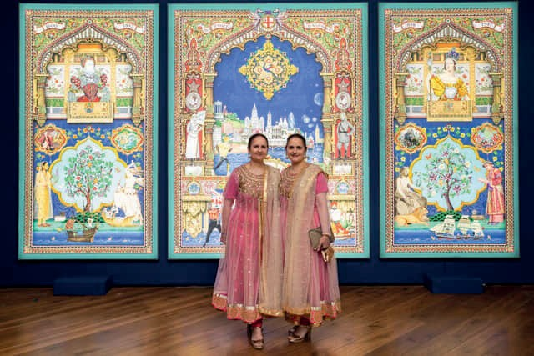
Amrit Singh MBE and Rabindra Kaur Singh MBE, known as The Singh Twins, are world-class British artists who have revolutionised contemporary art by reviving the Indian miniature tradition to tackle modern social and political issues. Their “eclectic” style is a brilliant fusion of global influences, blending everything from Persian manuscripts and Renaissance art to Victorian satire and photography.

I find their work particularly captivating because its intricate detail and incredible vibrancy strongly evoke the spirit of Janamakshi miniatures. Much like those historical illustrations, the Twins’ work uses a rich, saturated palette and dense storytelling to turn every canvas into a world worth exploring, successfully challenging narrow,
Euro-centric views of what “fine art” should look like.

Teachers can present their art work and ask students as a starter what they see, what they identify – how the twins have shown their religion or beliefs in the miniatures and possibly allow students to create their own style amplifying their own creative take on beliefs or worldviews.

Mata Khivi: The only woman named in the Guru Granth Sahib

Mata Khivi is the only woman mentioned by name in the Guru Granth Sahib, where she is praised for upholding core Sikh values of sewa, equality and compassion. As the wife of the second Guru, Guru Angad Dev Ji, she was mocked for selling her possessions and living simply. She organised hospitality for devotees, caring for the sangat after long journeys and playing a central role in establishingthe present-day langar system, later known as “Khivi ka Langar”. She also helped organise sewa within the community, and is described in the Guru Granth Sahib as a nurturing and noble figure who “distributes the bounty of the Guru`s Langar; the kheer - the rice pudding and ghee, is like sweet ambrosia.” Mata Khivi ji lived for thirty years after her husband’s death. She continued to serve the community and remained associated with the Guru’s house in all that time. Many langar halls in Gurdwaras in the UK are named after Mata Khivi honouring her sacrifice.

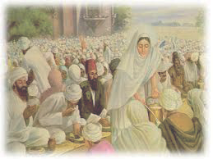

Teachers can present Mata Khivi as a historical example for Sikh women who helped sustain and shape langar, discussions could lead to students reflecting on whether they could act as Mata Khivi had done – give up inheritance to the poor and live a simple life serving others? What might stop them from being able to do this.

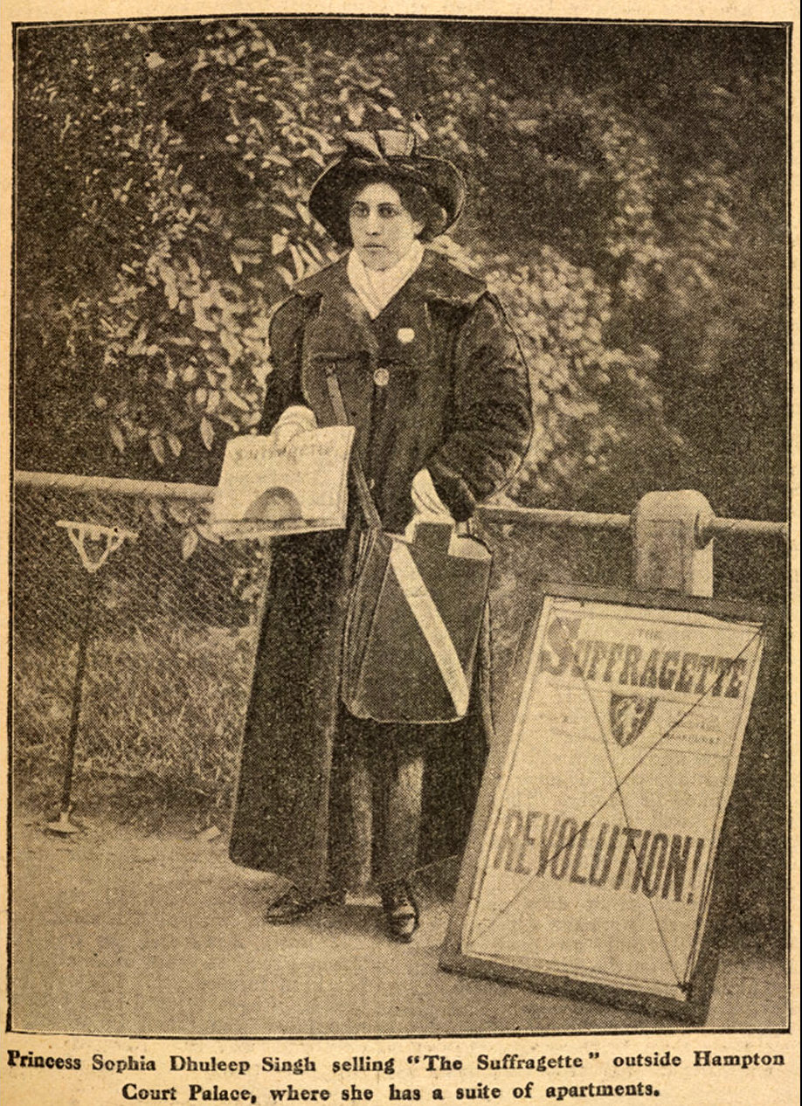
Sophia Duleep Singh: Suffragette
In her documentary, biographer Anita Anand highlights the remarkable life of Princess Sophia Duleep Singh, the daughter of the last Sikh Maharaja and goddaughter to Queen Victoria. A pivotal figure in the British suffragette movement, Sophia leveraged her royal visibility to fight for women’s rights while also serving as a dedicated nurse for Indian soldiers during the First World War.
Her 1924 tour of India drew massive crowds and helped bridge the gap between British and Indian women’s rights campaigns. Throughout her life, she remained a fearless advocate who used her unique position to challenge the establishment, support Indian
independence, and ensure that South Asian voices were represented in 20th-century Britain.
Teachers can use this as a historical example of a Sikh who fought for equality, she leveraged her ‘royal’ status to give rise to the suffrage movement and went as far as not paying her taxes – showing her Sikh conviction of all to be considered equal.

In her documentary, biographer Anita Anand highlights the remarkable life of Princess Sophia Duleep Singh, the daughter of the last Sikh Maharaja and goddaughter to Queen Victoria. A pivotal figure in the British Suffragette movement, Sophia leveraged her own royal visability to fight for women’s rights while also serving as a dedicated nurse for Indian soldiers during the First World War.

Her 1914 tour of India drew massive crowds and helped bridge the gap between British and Indian womens’s rightscampaigns. Throughout her life she remained a fearless advocate who used her unique position to challenge the establishment, support Indian independence, and ensure that South Asian voices were represented in 20th Century Britain.

Teachers can use Sophia as a historical example of a Sikh who fought for equality, she leveraged her ‘royal status to give rise to the suffrage movement and wemt as far as not paying her taxes- showing her Sikh conviction of all to be considered equal.

